

**Balancing A Full Time Job With Ministry**

*Jared Wells*

II Timothy 4:2*, Preach the word; be instant in season, out of season; reprove, rebuke, exhort with all longsuffering and doctrine.*

1. “Preach”
   1. Preach with you demeanor, “behavior”
   2. Preach with your attitude
   3. Preach with your dress
   4. Preach with your language
      1. During lunch breaks
      2. “You might be the only Bible someone is reading at work”
2. “Be instant”
   1. Get up early
      1. “The early bird gets the worm”
      2. When you get up early, you get more accomplished sooner in the day
   2. Get there early
   3. Get organized
      1. Do not procrastinate
      2. Prioritize
      3. Put your family serving with you
         1. **J**esus
         2. **O**thers
         3. **Y**ou
   4. Get busy
      1. If you want to ask someone to get something done, ask a busy person.
      2. They know how to manage their time
3. “In Season and Out of Season”
   1. On vacation, continue getting up early.
   2. Create small habits to help yourself.
      1. Set alarms
      2. Set reminders
      3. Put it in your calendar as “recurring”
   3. Learn ways to manage your time.
      1. Make a list before going to the store.
         1. Saves on forgetting something.
         2. Saves on second trips.
         3. Saves on buying too much.
      2. Make a list before going to make visits.
         1. Saves on missing someone.
         2. Saves on trying to remember everyone by heart.
4. “Reprove”
   1. Be willing to admit you have done something wrong.
   2. Be willing to apologize.
   3. Be willing to amend what you have done.
5. “Rebuke”
   1. Be ready to take rebuke.
   2. Be ready to give rebuke.
      1. Give rebuke how you would like to take it when given to you.
      2. Give rebuke with an admonishment.
6. “Exhort With All Longsuffering and Doctrine”
   1. Admonish those at work and in ministry when they follow instructions.
   2. Be long in suffering, not quick to snap.
   3. Rise to the challenge

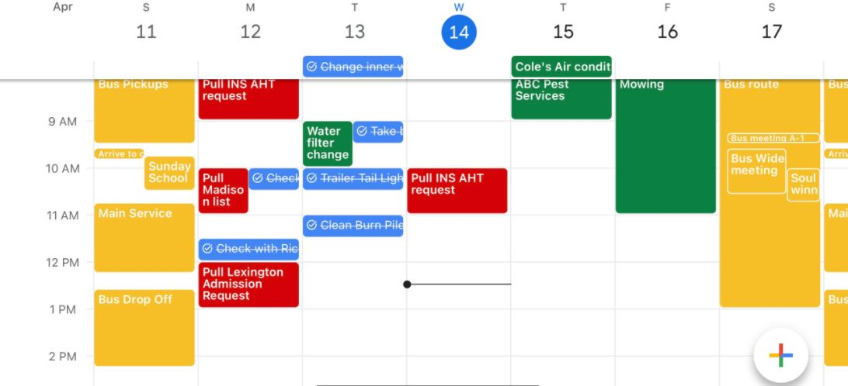

My Jobs:

1. Medical Records Coordinator
   1. File medical and financial files for over 20 rehab facilities.
   2. Destroy paper records once they reach their expiration.
   3. Pull INS request for residents.
   4. Pull OIG (Office Inspector General) request for rehab facilities.
2. Foreman for 342 Acres
   1. Mowing
   2. Grass treatments
   3. Garden maintenance and weed control
   4. Equipment Maintenance, Cleaning, and Service
      1. 2 UTV’s
      2. 1 ATV
      3. John Deere Tractor 5085M
      4. Bobcat T650
      5. 2 Zero Turn mowers
      6. Towing trailers
      7. Trucks
      8. Weed eaters
      9. Chainsaws
      10. Power tools etc...
   5. Trail upkeep
   6. Normal household maintenance
      1. Air filters
      2. Water filters
      3. Septic treatments
   7. Painting Maintenance
   8. Tree trimming
   9. Trash hauling
   10. Road and field grading
   11. Rodent maintenance
   12. Fuel maintenance
   13. Fence maintenance
   14. Splitting fallen trees
3. Mobile Notary
   1. Sellers packets
   2. Refinance Packets
4. Breed Labs
   1. Deworming
   2. Weaning
5. Online Business
   1. Mrs. Gadget Drop Shipping from *Shopify*
   2. Used *Aliexpress* for my orders
6. Have vending machines
   1. Keeping candy stocked
   2. Counting quarters
7. Own a house flipping business
   1. Have had 18 real estate transactions since 2016
   2. Closing on another house in May 2021
8. Stock trading
   1. Buying and selling my own stocks
9. Photo Shoots
   1. Graduations
   2. Weddings
   3. Engagement

My Ministries:

1. Sunday school teacher for 9th grade boys
2. Play piano for the youth department Sunday morning and evening.
3. Bus captain for bus A-1
   1. Consists of in home visits
   2. Weekly meeting with bus director
   3. Weekly meeting with my workers
   4. Soul winning in my areas
   5. Giving rides to church on Sundays
4. Camera man

Pictures for church events.

Past Ministries:

1. Jr. department head for B riders 8, 9, and 10 year olds.
2. Boy’s 10-year-old Sunday School teacher.