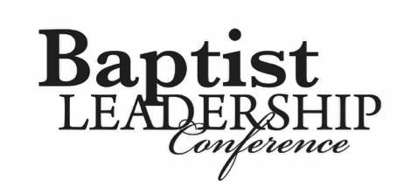

**Training Your Young Children to Serve the Lord**

*Mrs. Hannah Bell*

Proverbs 22:6, “*Train up a child in the way he should go and when he is old he will not depart from it*.”

1. Pray for your children.
2. Don’t compare your children.
3. Teach them to make God their God, not just yours.
4. Teach them at a young age to put God first.
5. Teach them how to serve God, and make it enjoyable.
6. Teach them to praise God in all things.
7. Teach them to be grateful for what they have.
8. Teach them to put others over themselves.
9. Don’t lead out of fear.
10. Praise and reward just as much, if not more, than you rebuke.
11. Teach them that when they sin, it breaks your heart; but more importantly, it breaks God’s heart.
12. Stay humble and apologize when needed.
13. Teach them how to be a good steward at a young age.
14. Be real, not double minded.
15. Make sure they know they are loved.